**1.Create restaurant app in react with all the functionalities**

**import React, { useState } from 'react';**

**import './App.css'; // Import CSS for styling**

**const App = () => {**

**const [customerName, setCustomerName] = useState('');**

**const [customerNumber, setCustomerNumber] = useState('');**

**const [selectedItem, setSelectedItem] = useState('1');**

**const [quantity, setQuantity] = useState(1);**

**const [specialInstructions, setSpecialInstructions] = useState('');**

**const [termsAccepted, setTermsAccepted] = useState(false);**

**const [orderDetails, setOrderDetails] = useState(null);**

**const [errors, setErrors] = useState({});**

**const menuItems = [**

**{ id: '1', name: 'Chicken biriyani' },**

**{ id: '2', name: 'Mutton biriyani' },**

**{ id: '3', name: 'Sweets' },**

**];**

**const images = [**

**'/images/pizza.jpg',**

**'/images/burger.jpg',**

**'/images/pasta.jpg',**

**];**

**const handleSubmit = (e) => {**

**e.preventDefault();**

**const newErrors = {};**

**if (customerNumber.length !== 10) newErrors.customerNumber = 'Contact number must be exactly 10 digits.';**

**if (quantity < 1 || quantity > 3) newErrors.quantity = 'Quantity must be between 1 and 3.';**

**if (Object.keys(newErrors).length > 0) {**

**setErrors(newErrors);**

**return;**

**}**

**const order = {**

**customerName,**

**customerNumber,**

**menuItem: menuItems.find(item => item.id === selectedItem).name,**

**quantity,**

**specialInstructions,**

**totalOrder: quantity**

**};**

**setOrderDetails(order);**

**setErrors({});**

**};**

**const handleReset = () => {**

**setCustomerName('');**

**setCustomerNumber('');**

**setSelectedItem('1');**

**setQuantity(1);**

**setSpecialInstructions('');**

**setTermsAccepted(false);**

**setOrderDetails(null);**

**setErrors({});**

**};**

**return (**

**<div className="App">**

**<header className="App-header">**

**<h1>Restaurant Page</h1>**

**</header>**

**<main className="container">**

**<nav>**

**<ul>**

**<li><a href="#order">Order Now</a></li>**

**<li><a href="#gallery">Gallery</a></li>**

**</ul>**

**</nav>**

**<section id="order">**

**<div className="form-container">**

**<h1>Restaurant Order Form</h1>**

**<form onSubmit={handleSubmit}>**

**<label>**

**Customer Name:**

**<input type="text" value={customerName} onChange={(e) => setCustomerName(e.target.value)} />**

**</label>**

**<label>**

**Customer Number:**

**<input type="text" value={customerNumber} onChange={(e) => setCustomerNumber(e.target.value)} maxLength="10" />**

**{errors.customerNumber && <p className="error">{errors.customerNumber}</p>}**

**</label>**

**<label>**

**Menu Item:**

**<select value={selectedItem} onChange={(e) => setSelectedItem(e.target.value)}>**

**{menuItems.map(item => (**

**<option key={item.id} value={item.id}>{item.name}</option>**

**))}**

**</select>**

**</label>**

**<label>**

**Quantity:**

**<input type="number" value={quantity} onChange={(e) => setQuantity(Math.min(3, Math.max(1, e.target.value)))} />**

**{errors.quantity && <p className="error">{errors.quantity}</p>}**

**</label>**

**<label>**

**Special Instructions:**

**<textarea value={specialInstructions} onChange={(e) => setSpecialInstructions(e.target.value)} />**

**</label>**

**{errors.terms && <p className="error">{errors.terms}</p>}**

**<button type="submit">Order Now</button>**

**<button type="button" onClick={handleReset}>Reset</button>**

**</form>**

**{orderDetails && (**

**<div className="order-summary">**

**<h2>Order Summary</h2>**

**<p>Customer Name: {orderDetails.customerName}</p>**

**<p>Customer Number: {orderDetails.customerNumber}</p>**

**<p>Menu Item: {orderDetails.menuItem}</p>**

**<p>Quantity: {orderDetails.quantity}</p>**

**<p>Special Instructions: {orderDetails.specialInstructions}</p>**

**<p>Total Order: {orderDetails.totalOrder}</p>**

**</div>**

**)}**

**</div>**

**</section>**

**</main>**

**<footer>**

**<p>&copy; 2024 Restaurant</p>**

**</footer>**

**</div>**

**);**

**};**

**export default App;**

App.css

.App {

font-family: Arial, sans-serif;

}

.App-header {

font-family: Arial, sans-serif;

background-color: ;

padding: 10px;

text-align: center;

}

nav ul {

list-style: none;

padding: 0;

margin: 0;

text-align: center;

}

nav ul li {

display: inline;

margin: 0 10px;

}

.container {

max-width: 800px;

margin: 0 auto;

padding: 20px;

}

.form-container {

background-color: hwb(261 6% 14%);

padding: 20px;

color: black;

border-radius: 8px;

box-shadow: 0 0 10px rgba(0, 0, 0, 0.1);

}

label {

display: block;

margin: 10px 0;

}

input[type="text"], input[type="number"], textarea, select {

width: 100%;

padding: 8px;

box-sizing: border-box;

}

button {

padding: 10px 15px;

margin: 10px;

cursor: pointer;

}

.error {

color: red;

}

.order-summary {

border: 1px solid #dddddd;

padding: 10px;

margin-top: 20px;

}

.gallery {

margin-top: 20px;

display: flex;

flex-wrap: wrap;

justify-content: center;

}

.gallery img {

width: 100px;

height: auto;

margin: 5px;

}

footer {

background-color: #f8f8f8;

padding: 10px;

text-align: center;

}

Output

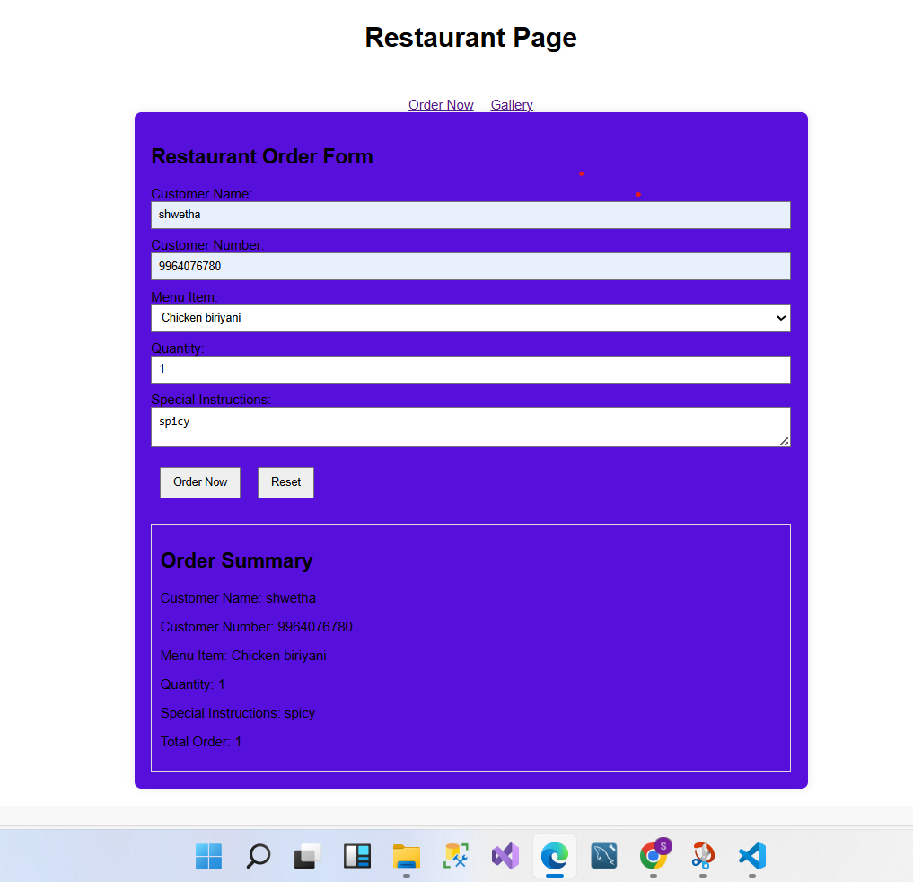

**2.Create a product listing app using HTML,CSS and react**

App.Js code

import React from 'react';

import '../App.css';

const Footer = () => {

return (

<div className='footer'>

<p>Shopping App 2024&copy;</p>

</div>

);

}

export default Footer;

Navbar.Js code

import React from 'react';

import '../App.css';

const Navbar = () => {

return (

<div className='navbar'>

<h1>Shopping App</h1>

</div>

);

}

export default Navbar;

Footer.Js code

import React from 'react';

import '../App.css';

const Footer = () => {

return (

<div className='footer'>

<p>Shopping App 2024&copy;</p>

</div>

);

}

export default Footer;

Product.Js code

import React, { useState, useEffect } from 'react';

import '../App.css';

import axios from 'axios';

const Products = () => {

const [loading, setLoading] = useState(true);

const [data, setData] = useState([]);

useEffect(() => {

axios.get('https://fakestoreapi.com/products')

.then(res => {

setData(res.data);

})

.catch(e => console.log(e))

.finally(() => setLoading(false));

}, []);

return (

<div className='products-container'>

{loading && <h1>Loading...</h1>}

{!loading && data.map((product) => (

<div className="card" key={product.id}>

<h2>{product.title}</h2>

{console.log(product.image)} {/* Log the image URL */}

<img src={product.image} alt={product.title} />

<p>{product.category}</p>

<p>${product.price}</p>

</div>

))}

</div>

);

};

export default Products;

App.css

* {

box-sizing: border-box;

padding: 0;

margin: 0;

}

.navbar {

width: 100%;

height: 10vh;

background-color: black;

display: flex;

align-items: center;

justify-content: space-between;

color: white;

padding: 10px;

font-weight: bold;

}

.products-container {

width: 100%;

min-height: auto;

display: grid;

grid-template-columns: repeat(4, 1fr);

justify-items: center;

margin-top: 20px;

margin-bottom: 20px;

}

.card {

display: flex;

align-items: center;

justify-content: center;

flex-direction: column;

margin: 20px 0;

}

img {

width: 250px;

height: 250px;

transition: all 0.3s ease;

}

img:hover {

transform: scale(1.1);

}

.footer {

width: 100%;

height: 10vh;

background-color: black;

display: flex;

align-items: center;

color: white;

justify-content: center;

font-size: 19px;

font-weight: bold;

margin-top: auto;

}

Output

